1. What is the output of the following program?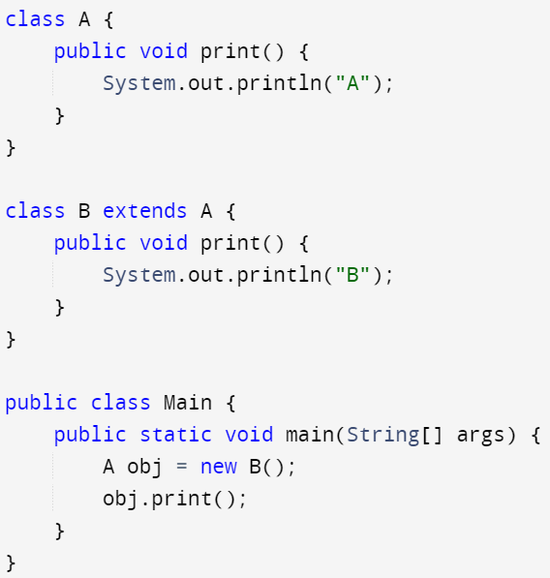
2. A
3. B
4. Error
5. None
6. In the following code, identify the constructor used. 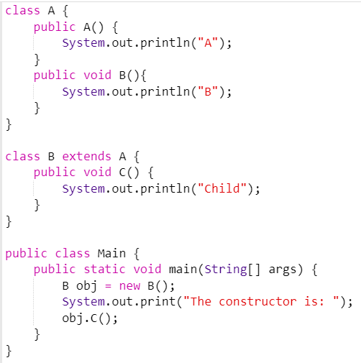
7. A
8. B
9. C
10. No constructor is used
11. Select the correct output of the following program: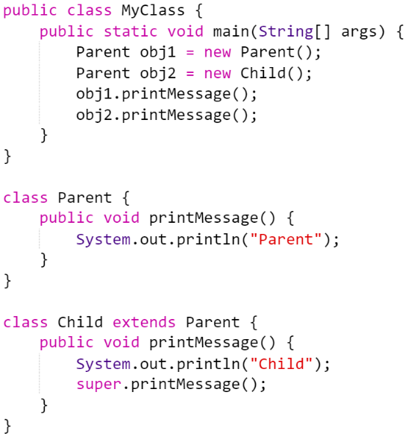
12. Parent  
    Child  
    Parent
13. Parent  
    Parent  
    Child
14. Parent  
    Child  
    Child
15. Error

3. When does method overloading is determined?

* 1. At run time
  2. At compile time
  3. At coding time
  4. At execution time

1. When does not method overloading occur?
   1. By changing number of arguments
   2. By changing the data type
   3. By changing the sequence of the data type
   4. By changing the return type
2. What is the output of the following program?

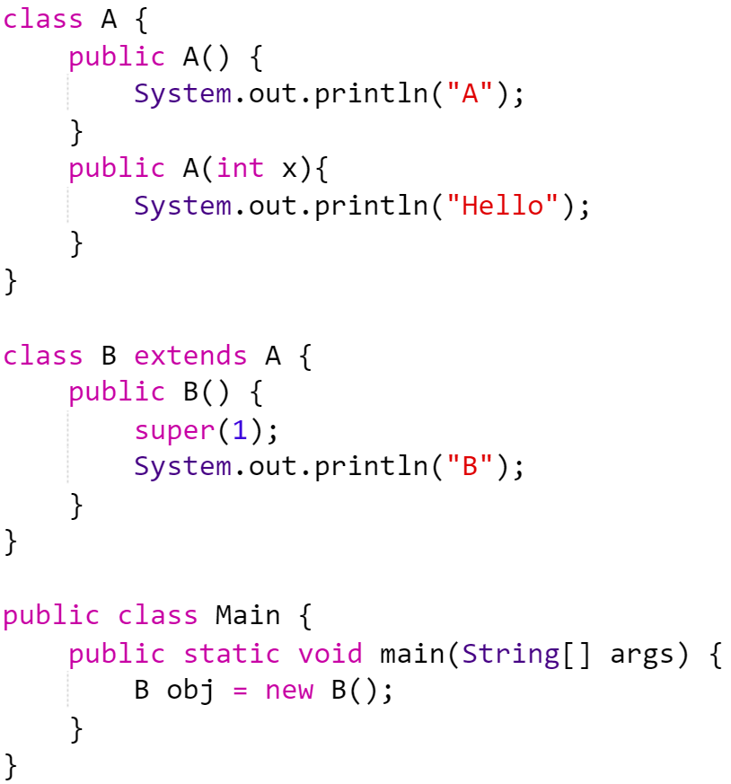

* 1. A  
     B
  2. Hello  
     B
  3. B
  4. Error

1. Select the correct output of the following code.

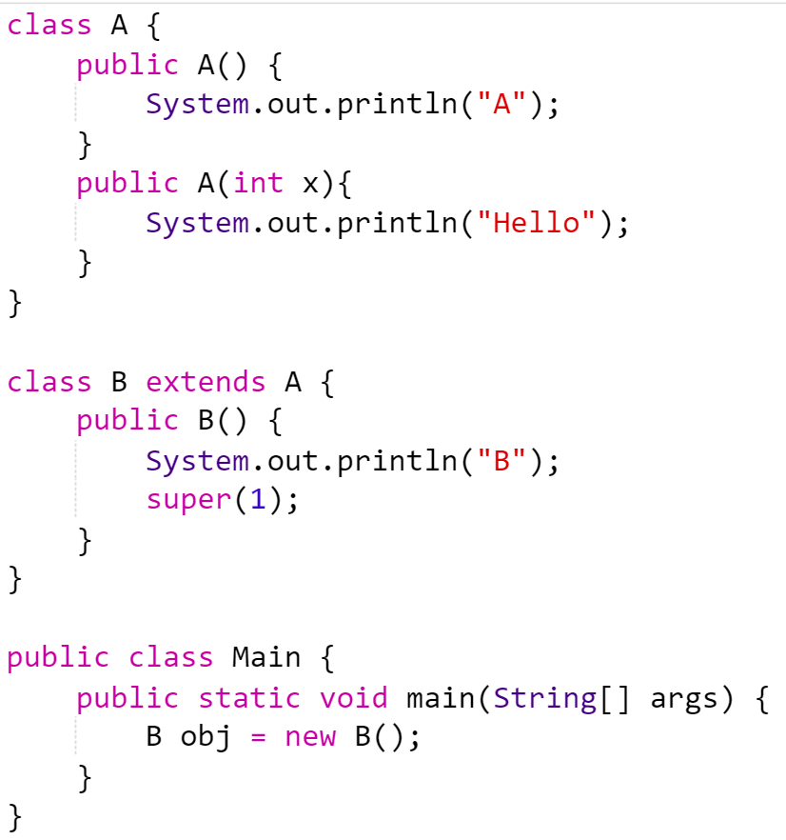

* 1. B  
     Hello
  2. B  
     A
  3. B
  4. Error

1. Predict the output of the following programs:
2. 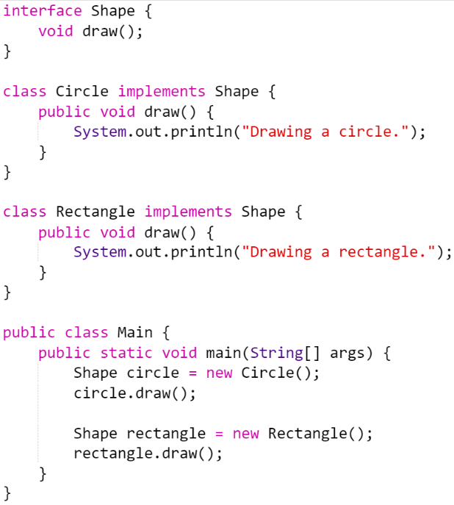
3. 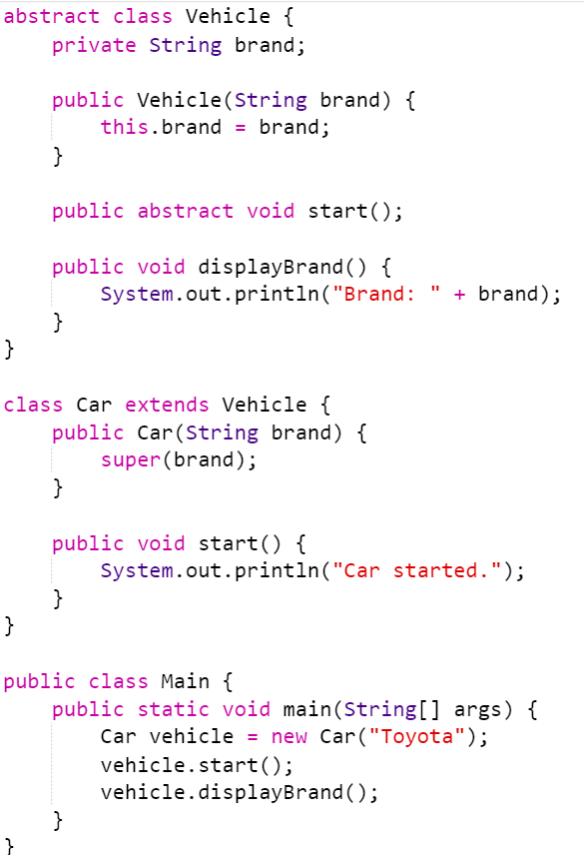
4. 